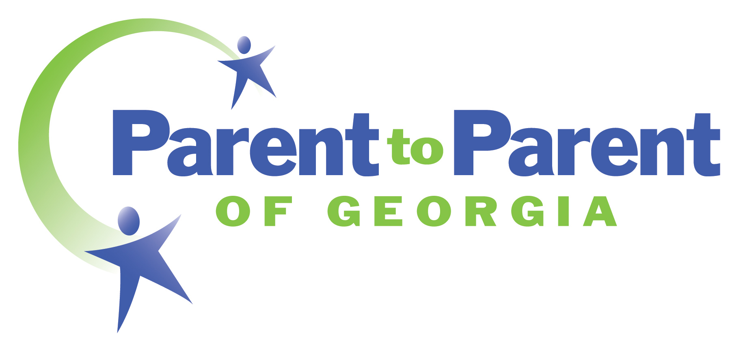

Board of Directors Interest Survey

- Are you a parent or family member of an individual with a disability or an individual with a disability yourself?
- Are you a professional working with individuals with disabilities and their families?
- Are you a community member who is interested in inclusive services for individuals with disabilities and their families?
- Do you want to make changes or improvements in Georgia for individuals with disabilities?
- Are you interested in serving in a leadership role for a statewide nonprofit also wanting to make changes and improvements in Georgia?
- Do you have a desire to volunteer with others who share this same passion?

Then submit your Interest Survey to learn more about opportunities with
Parent to Parent of Georgia’s Board of Directors!

Parent to Parent (P2P) is Georgia’s FIRST STOP for Information!
- We are Georgia’s Parent Training and Information Center (PTI)
Helping families work with early intervention and education systems so they can be EQUAL partners in educational decision making!

- We are Georgia’s Family to Family Health Information Center (F2F)
Supporting families in navigating Georgia’s health systems, and encouraging them to be active partners with their health care providers!

- We are the Babies Can’t Wait Central Directory
Providing much needed assistance to families when they may be the most vulnerable and scared, so they can build their confidence and skills!

- We are Georgia’s Member of P2P USA
Providing research-based best practice emotional support to families when they need it most!

What does the P2P Board look like?
- A majority of members are parents or family members of individuals with disabilities or who have a disability themselves.
- We want a STATEWIDE representation! We encourage Georgians from all areas of the state to join!
- We strive to represent the families we serve and encourage diversity in our Board Members.
- Some Members bring their knowledge and expertise from their work in the disability field.
- Other Members have other professional skills and expertise to share in conjunction with their desire to improve choices for individuals with disabilities!

What do I have to do?
Complete the Board Interest Survey and submit it in one of the three ways indicated at the bottom of that form. These forms will be reviewed periodically by members of the P2P Board. Candidates of interest will be contacted by members of the P2P Board for more information!

Funded in part by grants from The Office of Special Education Programs of the US Department of Education and The Maternal and Child Health Bureau of the US Department of Health and Human Services.

Mission, Vision, and Values Statement

Strategic Vision
To be the source of choice for support, information, education, and leadership development for Georgians with disabilities or special health care needs, ages birth to 26, and their families

Mission
To support Georgia families and individuals from birth to 26 impacted by disabilities or special health care needs

Values
We celebrate that we are all individuals with unique needs. Our lives naturally provide all of us both separate and shared experiences. We embrace diversity and full inclusion. We believe equity is equal access and opportunity to quality programs and services, based on those unique needs and experiences. We acknowledge that inequalities exist, and we strive to improve equity by increasing justice and fairness within the procedures and processes of institutions or systems, as well as in their distribution of resources. To reach one’s full potential and achieve an intended outcome, we work to advance fair treatment for all families in Georgia, and we hold ourselves accountable to put our words into practice. Our accountability may include questioning existing systems and advocating for new and innovative approaches that may clash with historical solutions as well as our own ideologies. Through reflection, repeatable skills, and organizational practice, we strive to meet the needs of all families throughout Georgia because we believe that every person has equal value regardless of disability, race, ethnicity, cultural and linguistic diversity, socioeconomic status, sex, gender and sexual orientation and their expression.

To offer equitable choices that result in positive outcomes for individuals with disabilities, we believe this…

About every family and individual:
- Every person has choices
- Every person can grow and build their capacity
- Every person is exactly where they ought to be at that moment
- Every person should feel comfortable when reaching out to P2P

About every P2P staff member:
- Every staff member is caring, empathetic and speaks from the heart
- Every staff member is responsive
- Every staff member is nonjudgmental and respectful of each individual’s unique needs
- Every staff member actively empowers families to seek and receive equitable access

About every Board of Director, volunteer, and community partner:
- Every person brings unique leadership to the organization
- Every person makes positive contributions to the organization
- Every person has the responsibility to uphold P2P’s mission, vision, and values
- Every person is a representative of the diverse families that we serve across the state

To achieve our shared beliefs, P2P staff members strive:
- To embrace lifelong learning and put new knowledge into practice
- To use effective and active listening skills
- To build and encourage positive relationships
- To respect confidentiality
- To respond to each parent’s/family’s need at that time
- To focus on positive resolutions
AND…
- To provide updated information and creative ideas to any family that requests our services.

Parent to Parent of Georgia (P2P)
Board of Directors

Basic Expectations of Volunteer Board Members

General Expectations:

● Know and demonstrate commitment to the organization's mission, goals, objectives, programs and functioning

● Recruit other policy and program volunteers

● Actively promote P2P services and programs in their community, and keep informed about what is going on in the organization

● Bring a sense of comradeship to the Board's deliberations while seriously considering all issues and carefully weighing all available options

● Become a financial supporter of Parent to Parent

● Serve in leadership positions or special assignments willingly and enthusiastically when asked

Meeting Expectations:

● Participate fully and openly in meetings – sharing insights, ideas and suggestions. Meetings take place at least quarterly, typically through video meetings on weekday evenings or other means as allowed according to our bylaws. Annually, participate in one in-person board retreat (typically Friday evening and Saturday) at rotating locations throughout Georgia.

● Make decisions on issues, policies, goals and objectives based on careful consideration of facts and all relevant data

● Maintain confidentiality of the Board's executive sessions, and speak for the Board or organization only when authorized to do so

● Suggest agenda items periodically for board and committee meetings to ensure that significant policy-related matters are addressed

If contacted by P2P for further consideration, you will be provided additional information on these expectations. Once successfully elected, you will learn more in our Board orientation process.
Parent to Parent of Georgia (P2P)
Board of Directors
2025 Interest Survey

Name:

Address:

City, State, Zip Code:

Telephone Number:

Email Address:

Languages Spoken:

Have you previously been served by P2P? Describe:

Are you a: (check one)
_____ Parent or Family member of a child/young adult with a disability. Current age of child/young adult _____ _____ Individual with a disability
_____ Professional working with individuals with disabilities
_____ Both Parent/Family Member and Professional
_____ Community Member with an interest in individuals with disabilities

1. Tell us about yourself and why you are interested in serving on the P2P Board of Directors?

2. Tell us why you feel you have the leadership qualities to serve on the P2P Board of Directors?

3. Do you have any understanding or experience with statewide non-profit governance? If yes, please describe.

4. After reviewing our mission, vision, and values, tell us why you feel these are important to any member of the P2P Board of Directors?

5. What is your dream or vision for families with children with disabilities in Georgia? How does this fit with Parent to Parent of Georgia?

6. Is there anything else you would like us to know about you and/or your interest in joining the Board?

Please indicate your understanding and agreement with each of the following statements by initialing on each line:
_______ I understand that this is merely an expression of interest to possibly join the Board of Directors of P2P.
_______ I understand that this interest survey will be reviewed by members of the P2P Board and if they are interested in learning more about me, I will be contacted.
_______ I understand that the P2P Board makes final decisions about membership as dictated in agency bylaws. I may accept or reject any position offered to me as a result of completing this survey.

Submit by email to P2PBoard@p2pga.org
By fax to 770-458-4091, or
By mail to Parent to Parent of Georgia, attn: Board Interest Survey
3070 Presidential Parkway, Suite 130, Atlanta, GA 30340

